# Question 1

## What is the cost of index search?

Number of estimated tuple

$=80000∙\frac{1}{5}∙\frac{600-100}{10000-0}=800$

Tuples on each leaf

$=\frac{80000}{500}=160$

Total cost

$floor\left(\frac{800}{160}\right)+1+2+800=8+800$

## What is the additional cost of the block-nested join on top of the index search?

Page num $=ceil\left(800∙\left(5*8\right)∙\frac{1}{6000}\right)=6$

Cost $=ceil\left(\frac{6}{23}\right)∙4000=4000$

## What is the additional cost of the sort on top of the cost of index search and join?

Calculate tuple after join $=800∙600 000∙\frac{1}{\max\left\{values\left(R.B\right), values\left(S.G\right)\right\}}$ $$=800∙60=48000$$

Page needed $=48000∙\left(8∙8\right)∙\frac{1}{6000}=512$ Total sorting cost $512∙\left(floor\left(\log_{100}{512}\right)\right)∙2=1024$

## What is the total cost of this query plan

Total cost $=8+800+4000+1024=5832$

# Question 2

1. (R join S) join T
$$R join S=200+\left(\frac{200}{200}∙1200\right)=1400 \\ \left(R join S\right) join T=\frac{8000}{200}∙4000=160000 \\ total=161400$$

2. (R join T) join S

$$R join T=200+\left(\frac{200}{200}∙4000\right)=4200 \\ \left(R join T\right)join S=\frac{2000}{200}∙1200=12000 \\ total=16200$$

# Question 3

S: r1(x) r2(z) r1(y) w2(w) w2(z) r3(z) w3(x) r1(w) w1(y) w3(z)

r2(z) w2(w) w2(z) r1(x) r1(y) r1(w) w1(y) r3(z) w3(x) w3(z)

## List all conflicts

r1(x) w3cdx(x)

r2(z) w3(z)

w2(z) w3(z)

w2(z) r3(z)

w2(w) r1(w)

## Check if schedulable

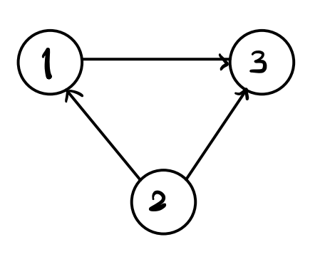

There is no potential conflict

## 2PC

Yes it is possible, there is one listed potential schedule

Re